**Experiment 4B**

**PART A**

**To implement basic connection establishment by using Packet Tracer Software**

**A.1—Aim:**

The purpose of this session is to implement the basic connection and sending echo messages from one device to another using packet tracer software

**A.2--- Prerequisite:**

Understanding the basic knowledge of connecting devices

**A.3--- Outcome:**

After successful completion of this experiment students will be able to:

• Interact the basic interface of the Packet tracer software

**A.4--- Procedure:**

**Task:**

1. To connect client to server

2. See the simulation of sent and received packet using general and complex PDU

3. Check the OSI layers of the packet

*4.* Observe the output and complete PART B of lab manual

5. Save and close the file and name it as **EXP4_ your Roll no.**

**PART - B**

|  |  |
| --- | --- |
| Roll. No. A016 | Name: Varun Mahendra Khadayate |
| Class B.Tech CsBs | Batch: 1 |
| Date of Experiment: 29-01-2022 | Date of Submission:05-02-2022 |

**B.1: Procedure of performed experiment**

1. In Cisco Packet Tracer, create a connection in Logical Mode.

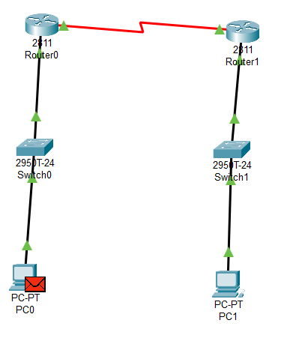

1. Click on both the PC simultaneously and click on Desktop and select IP Configuration, a new box will open. In that box under the IP Configuration section, assign the IP addresses as 192.168.10.1 and 192.168.20.1 respectively of both the PC. Also add the default gateway as the IP Addresses of Router0 and Router1 respectively as 192.168.10.2 and 192.168.20.2.

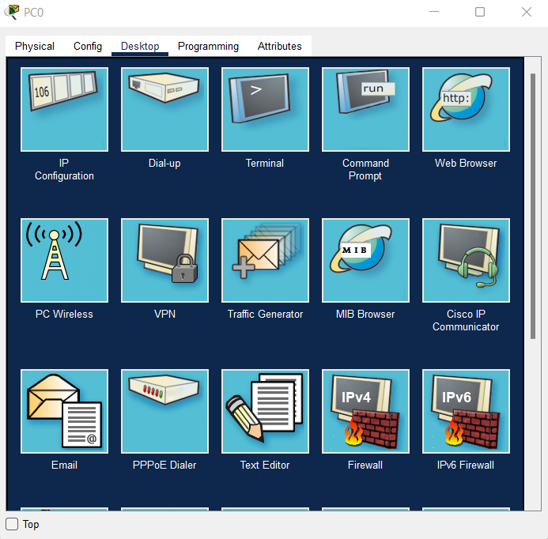

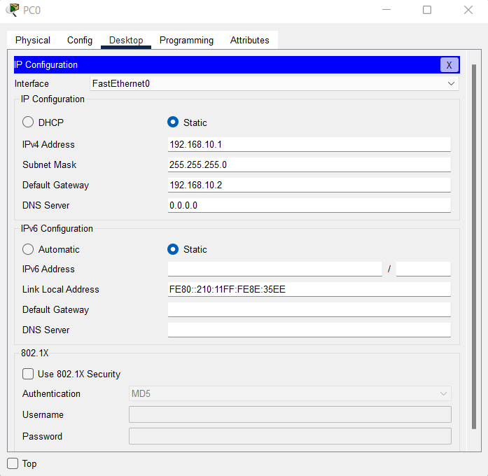

1. Now configure the two Routers by adding a serial port and adding their respective IP Addresses as 192.168.30.1 and 192.168.30.2 respectively.

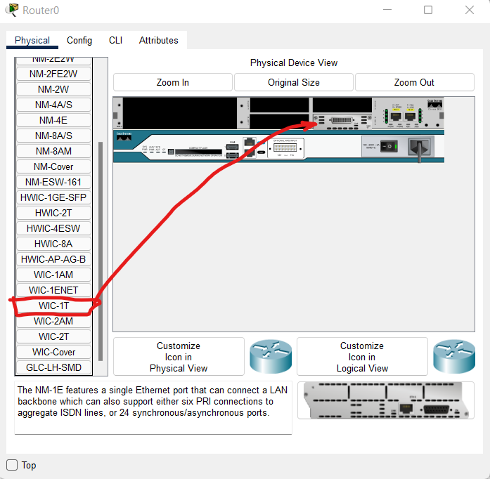

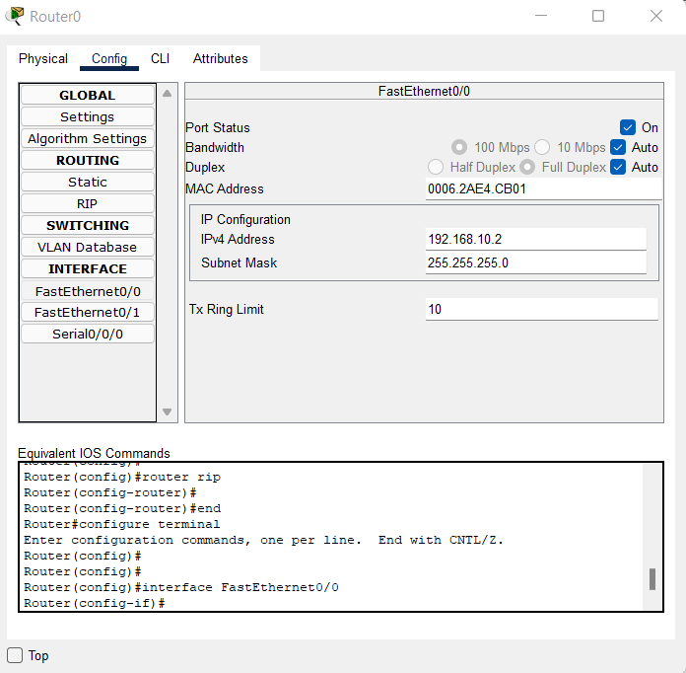

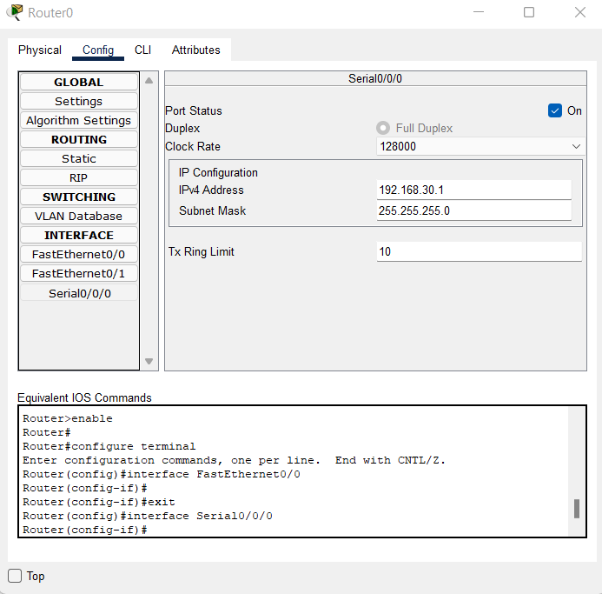

1. Now from the task bar select the ‘Add simple PDU’ button and select PC0 one by one and start the simulation to see the message parsing.

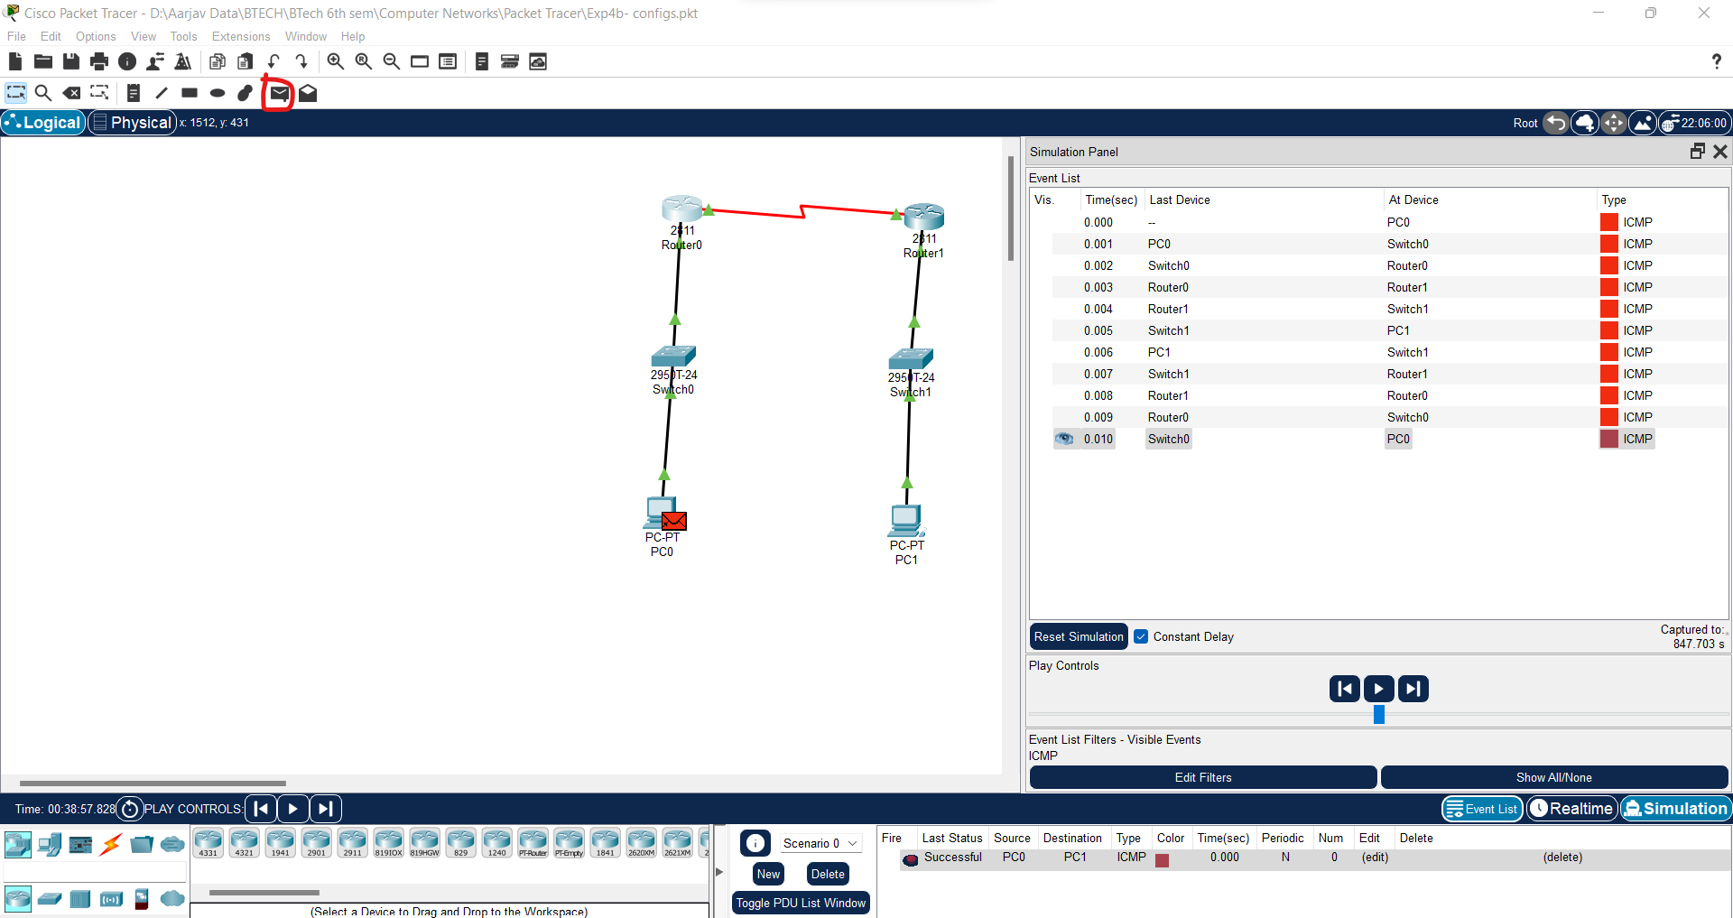

**B.2: Observations and Learning’s:**

### Initial State:

message is at PC0 and the parsing has not been started yet. There is only out layer because the message will be outgoing and nothing is coming in.

#### Layer 1:

shows the port connection (i.e., FastEthernet0) from where the message will be transferred.

#### Layer 2:

the MAC addresses have been determined and the flow is built.

#### Layer 3:

destination and source IP Addresses have been mentioned.

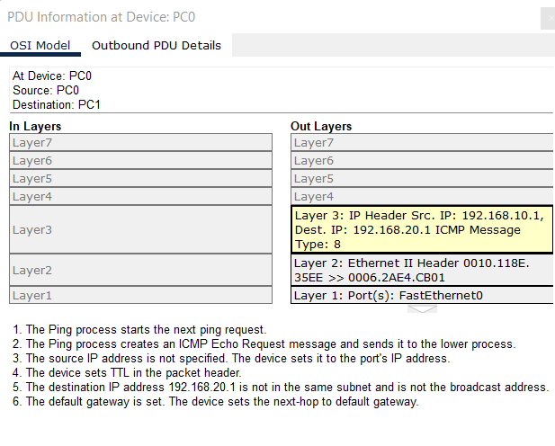

### PC0 to Switch0:

Now the message is transferred to switch from the FastEthernet0 port, message from PC0 will be coming in and later the message will be going out so both In and Out layers will be used.

#### In Layer 1:

message coming in through FastEthernet0/1.

#### In Layer 2:

Mac address flow is shown from PC0 to swtich0.

#### Out Layer 1:

message will be going out from FastEthernet 0/2.

#### Out Layer 2:

Mac addresses flow is setup from switch0 to PC1.

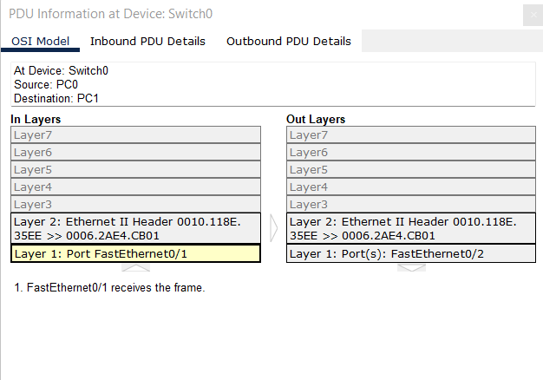

### Switch0 to Router0:

Now FastEthernet0/2 of Switch0 transfers the message to Router0, in layers show 3 layers for incoming message, Out Layers shows 3 layers for the message going to Router1.

#### In Layer1:

Message arrived at FastEthernet0/0 port of Router0 from Switch0.

#### In Layer2:

Mac addresses connection shown.

#### In Layer3:

Flow of message from source to Router in IP Adresses.

#### Out Layer1:

Message will be transferred to Serial0/0/0 port of Router1.

#### Out Layer2:

Mac addresses connection built between Router0 to Router1

#### Out layer3:

The source and destination for message determined.

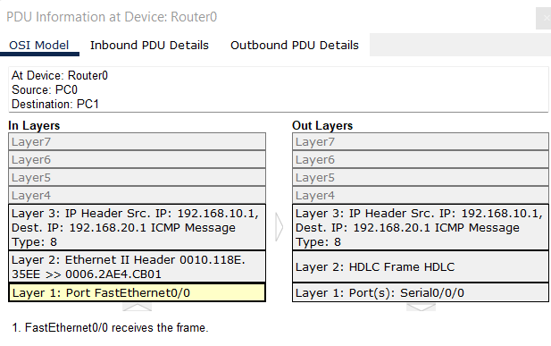

### Router0 to Router1:

Now Serial0/0/0 of Router0 transfers the message to Router1, in layers show 3 layers for incoming message, Out Layers shows 3 layers for the message going Switch1.

#### In Layer1:

Message arrived at Serial0/0/0 port of Router1 from Router0.

#### In Layer2:

Mac addresses connection shown.

#### In Layer3:

Flow of message from source to Router in IP Addresses.

#### Out Layer1:

Message will be transferred to FastEthernet0/0 port of Switch1.

#### Out Layer2:

Mac addresses connection built between Router1 and Switch1.

#### Out layer3:

The source and destination for message determined.

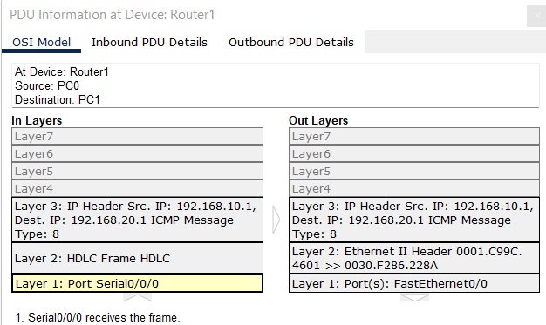

### Router1 to Switch1:

Now Serial0/0/0 of Router1 transfers the message to Switch1, in layers show 2 layers for incoming message, Out Layers shows 2 layers for the message going to Switch1.

#### In Layer1:

Message arrived at fastethernet0/2 port of Switch1 from Router1.

#### In Layer2:

Mac addresses connection shown.

#### Out Layer1:

Message will be transferred to fastethernet0/1 port of PC1.

#### Out Layer2:

Mac addresses connection built between Switch1 to PC1

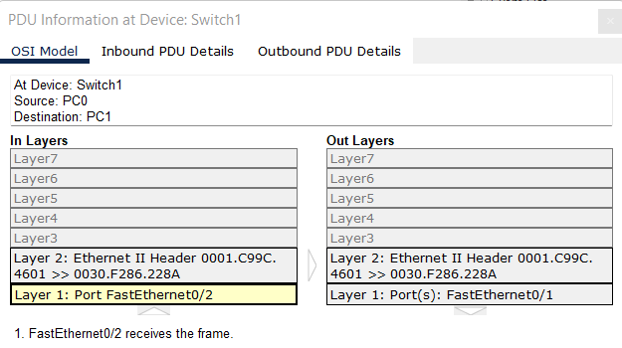

### Switch1 to PC1:

The message has reached its destination i.e., PC1 from Switch1, In Layers shows 3 layers for incoming message and Out Layers shows the 3 Layers for message going back to source.

#### In Layer1:

Message arrived at fastethernet0 port of PC1 from Switch1.

#### In Layer2:

Mac addresses connection shown.

#### In Layer3:

Flow of message from Switch1 to PC1 in IP Adresses.

#### Out Layer1:

Message will be transferred to fastethernet0 port of Switch1.

#### Out Layer2:

Mac addresses connection built between PC1 to Switch1

#### Out layer3:

The source and destination for message determined.

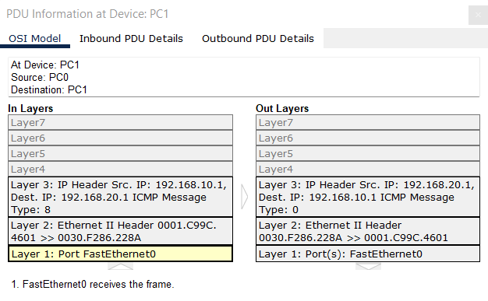

### The message will flow from PC1 to Switch1 then from both Router1 and Router0 and finally to PC0 and layers will be built similar to the above fashion

**B.3:  Conclusion:**

We were able to configure PC and Router and simulate a message transfer from one PC to another.